Kings Heath Primary School

Attendance & Punctuality Policy

RESPONSIBILITY: Headteacher
Governor: Danny Beusch

Last reviewed on: | February 2026
Next review due by: | February 2027

Our Vision
“Nurturing ambition, achievement, respect and happiness”
Kings Heath Primary School is a diverse and inclusive community of learners. We aspire for our children to become
- Confident: Academically, as a learner and in their identity
- Curious: of the world and people around them, and able to think critically
- Caring: of the world, people in it and of themselves
We believe in education and learning that is stimulating, liberating, and enriching and that helps develop minds that are alive to the diversity of human thought and achievement and to the richness of the natural world.
We aim to realise our vision in part through the fair and consistent operation of this policy.
Kings Heath Primary School is committed to the principles of the UNICEF Rights Respecting Schools Award (RRSA). We recognise that every child has the right to education (Article 28) and the right to develop to their full potential (Article 29). Promoting good attendance is therefore a key part of ensuring that children can access their rights fully.
Through our Rights Respecting approach, we promote a culture of belonging, safety and inclusion where children feel valued, listened to and supported to attend school regularly. We recognise that poor attendance can sometimes indicate that a child’s rights are not being fully realised, and we will work with families and external agencies where needed to remove barriers to attendance and participation in education.
Attendance expectations are balanced with our commitment to acting in the best interests of the child (Article 3). Where attendance difficulties arise, the school will seek to understand and address underlying needs through a supportive, child-centred and graduated response.
Legislation and guidance
This policy meets the requirements of the school attendance guidance from the Department for Education (DfE), and refers to the DfE’s statutory guidance on school attendance parental responsibility measures. These documents are drawn from the following legislation setting out the legal powers and duties that govern school attendance:
- The Education Act 1996
- The Education Act 2002
- The Education and Inspections Act 2006
- The Education (Pupil Registration) (England) Regulations 2006
- The Education (Pupil Registration) (England) (Amendment) Regulations 2010
- The Education (Pupil Registration) (England) (Amendment) Regulations 2011
- The Education (Pupil Registration) (England) (Amendment) Regulations 2013
- The Education (Pupil Registration) (England) (Amendment) Regulations 2016
- The Education (Penalty Notices) (England) (Amendment) Regulations 2013

By law, all schools (except those where all pupils are boarders) are required to keep an attendance register, and all pupils must be placed on this register.

The attendance register will be taken at the start of the first session of each school day and once during the second session. It will mark whether every pupil is:
- Present
- Attending an approved off-site educational activity
- Absent
- Unable to attend due to exceptional circumstances Any amendment to the attendance register will include:
- The original entry
- The amended entry
- The reason for the amendment
- The date on which the amendment was made
- The name and position of the person who made the amendment

See appendix 1 for the DfE attendance codes.

Every entry in the attendance register will be preserved for 3 years after the date on which the entry was made.

Introduction
The Governors and staff at Kings Heath School are united in their belief that regular school attendance is the key to enabling children to maximise the educational opportunities available to them. Helping them to become emotionally resilient, confident and competent adults who are able to realise their full potential and make a positive contribution to their community.
Kings Heath Primary School values all children. As set out in this policy we will work with families to identify the barriers to achieving and maintaining excellent attendance and offer the right service at the right time to try to resolve any difficulties.
The Attendance Leader (Mark Court - Headteacher) and Attendance Officer (Kath O’Shea) will monitor attendance and use attendance data to identify any patterns of concern, whilst also celebrating success! Attendance concerns will be raised with parents if reasons are not known by the school, e.g. a long period of illness, this information may be shared with the Local Authority following concerns. Where we have concerns, or lack of engagement from families to improve attendance, we will follow the schools escalated approach to improving attendance. The schools escalated approach is child-centred and prioritises support and developing strong working relationships with families. We will use the early help process to provide support prior to escalation and consider how we can work with families to enable your child to access their right to education.

Our aim is to always to work in partnership with parents and any referral for consideration of a penalty notice is deemed to be a last resort at Kings Heath. Attendance figures for each child will be reported to parents as part of the annual report, we will also share a child’s attendance profile if we have concerns regarding a child’s attendance. Throughout the school year the Attendance Team will report on the overall attendance figures for children groups, this will be closely monitored for support and reported to the Governing Body.
Where support strategies have not improved attendance, the school will follow Birmingham City Council Fast Track Attendance procedures and consider Parenting Contracts, Education Supervision Orders, Fixed Penalty Notices or prosecution under Section 444 Education Act 1996. Evidence of support and reasonable adjustments will be documented prior to enforcement.

To support good attendance, and safeguarding, at Kings Heath we:

- Ensure the school is welcoming and every child feels a sense of belonging and connectedness.
- Ensure the school site is open at the stated times.
- Ensure the regular, efficient, and accurate recording of attendance is complete by every class teacher each day. This further supports our approach to safeguarding within the school.
- Take safeguarding seriously and we will always contact you on the first day that your child is absent from school, this includes before and after-school clubs. If your child arrives late after the close of registration, we will record their arrival at reception and transition the child to class.
- Consider any requests for leave in term time individually. This will be aligned to the Local Authority code of conduct.
- Notify the Local Authority within 5 days if a new child is joining the school roll.
- Inform the Local Authority of children whose parents have notified the school in writing and have opted for Elective Home Education.
- Work closely with the School Attendance Support Team.
- Notify the Local Authority of Children Missing in Education – aligned to the DfE 2024 Working Together to Improve Attendance paper.

A whole school approach to supporting attendance at Kings Heath

Securing good attendance at Kings Heath cannot be achieved in isolation, and effective practices for improvement will involve working closely with other Leaders within the school. The Attendance Leader will work alongside the Curriculum Leaders, Behaviour Leader, SENDCo and Pupil Premium Leader to facilitate a whole school approach.
Attendance is treated as a primary safeguarding indicator. Sudden attendance change, patterns of absence or unexplained absence are reviewed through safeguarding processes and may trigger early help or safeguarding referral where thresholds are met.

The Strategic Approach

Kings Heath Primary School adopts the 5 Foundations of Effective Attendance Practice framework, this is modelled on the work of Professor Katherine Weare. The emphasis is on developing a school culture and climate which builds a sense of connectedness and belonging to ensure all children can attend school and thrive. The approach ensures we prioritise building solid working relationships with children, and parents, prior to escalation. The staged approach we follow ensures we identify triggers early that can lead to poor attendance issues such as mental health issues, lack of trust, communication and relationship breakdowns and the possible lack of networking opportunities both internal (in-school) and external (external agencies).

Aims of the 5 Foundations strategy

Increase school Attendance and reduce Persistent Absence to meet set targets.

Ensure Attendance is well managed within the school, with the appropriate level of resources allocated.

Enable the school to make informed use of attendance data to target interventions appropriately, focusing on the key demographic groups highlighted in the 2024 DFE Working Together to Improve Attendance paper.

Objectives
- create an ethos within the school in which good attendance is recognised as the norm and every child aims for excellent attendance.
- make attendance and punctuality a priority.
- set focused targets to improve individual attendance and whole school attendance levels.
- embed the 5 Foundations of Effective Attendance Practice framework which defines agreed roles and responsibilities and promotes consistency in carrying out designated tasks with respect to promoting attendance and punctuality.
- record and monitor attendance and absenteeism and apply appropriate strategies to minimise absenteeism.
- develop a systematic approach to gathering and analysing relevant attendance data.
- provide support, advice and guidance to; parents, children and develop mutual cooperation between home and the school in encouraging good attendance and in addressing identified attendance issues.
- Demonstrate, using rewards, that the school recognises good attendance and punctuality are achievements in themselves.



5 Foundations of Effective Attendance Practice
The main aim of the framework is to ensure the school promotes a culture of good attendance and celebrates success. Ultimately, the framework will ensure there is a culture of feeling safe and school being a place where children want to be.
Positive health and emotional well-being are key factors in improving social development, school attendance and educational achievement. The 5 Foundations of Effective Attendance Practice model promotes, and supports, a whole school approach to mental health and emotional well-being; ensuring SEMH support remains a key driver in improving attendance for all children.
Each Foundation is supported by 5 Key Performance Indicators, these are used to ensure the school can embed the Foundations framework and understand the strategic direction regarding attendance improvement. Each year the school will use the 5 Foundations self-assessment tool to understand what works well and identify what we need to do even better. We then follow the 5 Foundations school improvement process to implement the attendance plan and ultimately improve the lives of children and families we work with.

The school has a fully embedded ethos in which excellent school attendance is expected, developed and nurtured. The escalated approach to supporting attendance is built on foundations of belonging and connectedness.

The approach to improving attendance is built on clear policies, systems and processes. This ensures continuous and sustainable improvement drives attendance practice. The attendance policy is understood by all stakeholders and allows the school to set, and maintain, high expectations to improve the culture of attendance.

The school prioritises developing a team of attendance experts, with a shared vision and core purpose. The Attendance Leader delivers bespoke training to support all staff to fully understand their role in improving attendance. External partnerships support attendance improvements through a multi-disciplinary approach for identified children and families.

Data information and analysis direct resources proactively towards key demographic groups and identified individuals. The expert use of data analysis informs decision making at all levels. The attendance process ensures the Attendance Leader understands the reason for attendance concerns, these barriers can then be successfully supported and removed.
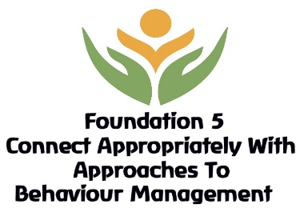
Connecting and belonging drives the school approach to supporting attendance. All staff are supported to understand 'deeper roots' regarding poor attendance concerns. The school has developed, and embedded, an effective rewards system to further drive attendance improvements and celebrate success.
DFE: Working Together to Improve Attendance paper 2024

From September 2024 the DFE: Working Together to Improve Attendance paper replaced all previous guidance on school attendance except for statutory guidance for parental responsibility measures.
The table below identifies how the 5 Foundations of Effective Attendance Practice w underpins the DFE 2024 paper.
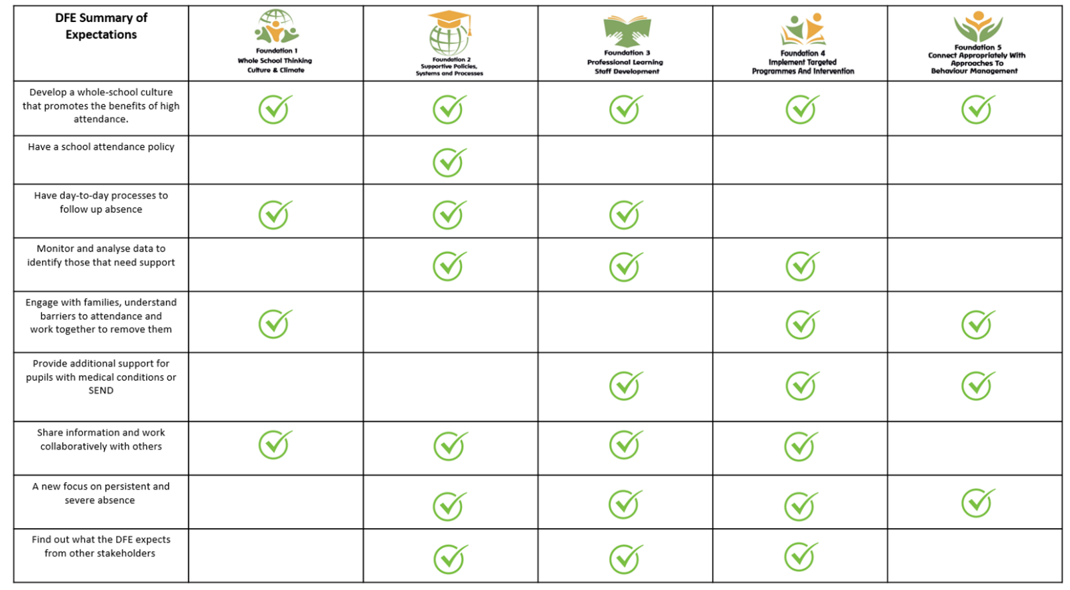

Kings Heath Primary School will always work in partnership with our parents
Kings Heath Primary School recognises that poor attendance is often an indication of difficulties in a child’s life and their lived experience. This may be related to problems at home or in school. Parents should inform the school of any difficulties or changes in circumstances that may affect their child’s attendance and or behaviour in school, for example, bereavement, divorce/separation, incidents of domestic abuse. This will help the school to identify any additional early help that may be required. Safeguarding is a priority, concerns for any child at any time will be reported to the Designated Senior Lead for Child Protection Paul Clabon. We will always follow Keeping Children Safe in Education and our Child Protection Policy.
Some children are more likely to require additional support to attain good attendance, for example, children who are vulnerable, have a medical need or EHCP plan will be monitored and supported in school. At Kings Heath we will proactively identify and follow up on a child’s non-attendance and gather information about the child. This will result in taking early action to prevent non-attendance developing and monitoring the impact of targeted support.
The school recognises strong links between attendance and mental health and will work with families, NHS services and external partners where mental health impacts attendance.
The Attendance Officer will initially:
- Check records, including any from other schools which the child has attended previously.
- Discuss with staff how the child is coping with the curriculum
- Speak to the Special Educational Needs Coordinator to establish whether the child is on the Special Educational needs register.
- Take into account the voice of the child and understand any difficulties, e.g. curriculum or bullying and their views on the issue could be addressed.

Children whose attendance falls below 90% are Persistently Absent from school, where a child falls under 50% attendance the child will be classified as a Severely Absent child. Ultimately this will indicate that all intervention, and support, offered by Kings Heath Primary School has not made the expected impact to improve overall attendance. Where attendance remains a concern and all other interventions and support have not made a significant impact, we will escalate with external partners.

Attendance Support Map
We will always support children during each stage of our Attendance Support Map. If there is lack of engagement, or concerns regarding the reason for absence, we will follow the Attendance Map to ensure we prioritise a child’s learning and right to education.

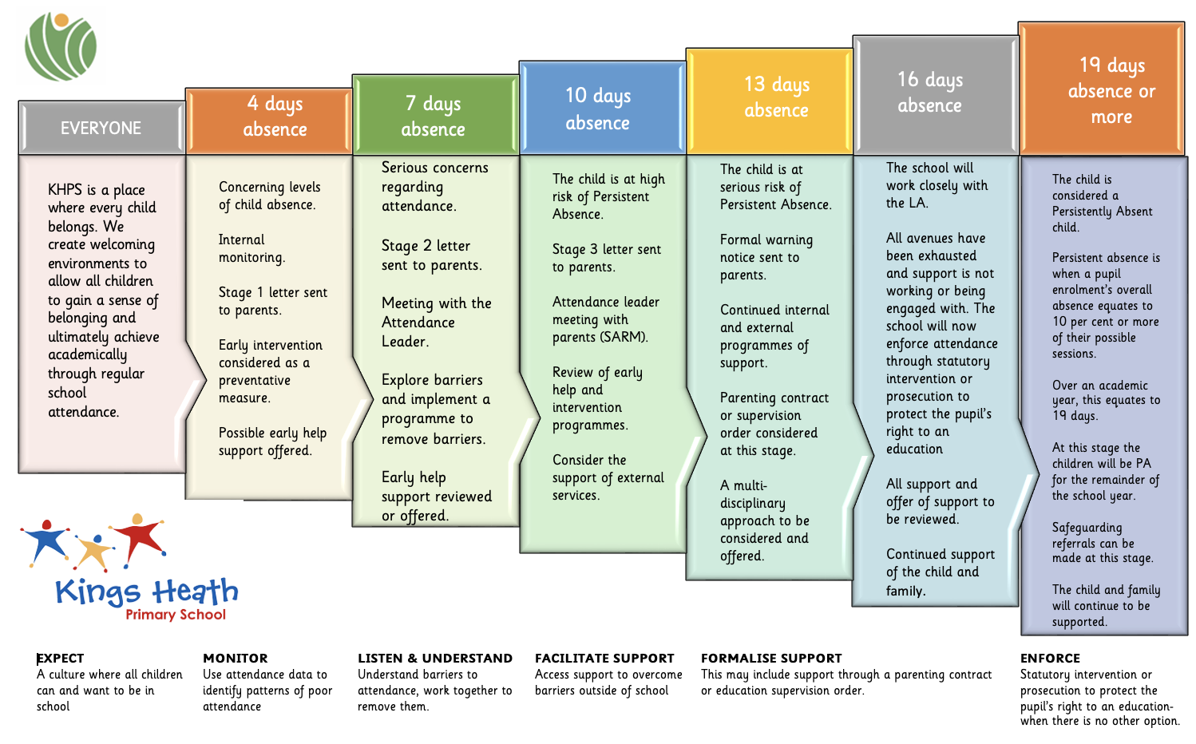

First Day Contact
At Kings Heath Primary School we expect our parents to make contact at the earliest opportunity on the first day of any absence. We will always contact you via text message or by calling you. Where we have on-going concerns regarding your child’s attendance, we will visit your home address and write to you. We may even invite you to meet with a member of staff to discuss any on-going concerns regarding attendance. It is important that you talk to us first; you are legally responsible under Education Act 1996 for ensuring that your child is in school every day and on time. If we cannot make contact with you, we will continue to make announced and unannounced home visits, regarding any concerns we may have surrounding attendance at Kings Heath Primary School.

Parents are responsible for securing full-time education
Parents are responsible for ensuring their children receive a full-time education. Each situation will be dealt with on an individual basis, fairly and equitably always remembering the welfare and safety of the child is the paramount concern.
The term ‘parent’ includes those who are not a natural parent but have parental responsibility for the child as defined by the Children’s Act 1989 or have care of the child as defined by the Education Act 1996.
- Absence can only be authorised by the school; parents do not have this authority. All absences will be treated as unauthorised unless satisfactory evidence for the child’s absence has been received. In the first instance contact from the parent will be accepted as evidence. However, if a child’s attendance continues to cause concern, parents may be asked to provide medical evidence where absences occur repeatedly due to reported illness. This will usually be in the form of an appointment card, prescriptions etc. Absence may be coded as unauthorised without evidence.
- Parents should wherever possible make all medical and dental appointments outside of the school day. Where this is not possible, children should attend school for part of the day. Appointment cards should always be provided as evidence of medical/dental appointments.
- Unless parents have provided a satisfactory explanation and it has been accepted by the school absence will not be authorised.
Please view the list of responsibilities and expectations regarding parents.
Examples of unsatisfactory explanations include:
- A child’s/family member’s birthday.
- Shopping.
- Having their hair cut.
- Closure of a sibling’s school for INSET or other purposes.
- “Couldn’t get up”.
- Illness where the child is considered well enough to attend school without medical authority and in the absence of a communicable disease.
- Leave during term time taken without authorisation of the school
- Head lice – let the school know and letters will then be sent to all parents in a confidential manner.

Punctuality
Doors open for children at 08:50am, the class register will close at 09:05 am. Children arriving after the close of registration will be recorded as late. Late marks will not be authorised and will count as an absence for the school AM session. Punctuality is recorded and this will be added to your child’s record of attendance, a letter will be sent to parents every half term regarding attendance concerns of a child. If a child arrives at school from 09:25am they will be U coded.
The absence will only be authorised if a satisfactory explanation for the late arrival can be provided, for example, attendance at a medical appointment.
The absence will be recorded as unauthorised if a child has arrived late without justifiable cause, for example they woke up late or were waiting for their clothes to dry.
Transition following long term absence or illness
Absence can significantly interrupt the continuity of children’s learning.

During any long-term absence, Kings Heath Primary School will:
- Maintain contact with the child.
- Carefully plan the transition back to school, ensuring your child feels welcome and gains a sense of belonging.
- Ensure the child once again feels safe in school and if they experience any concerns, they will have an appointed member of staff to work with.
- The Class Teacher and Teaching Assistant will support a child when returning to class and help them with any work they may have missed.

Leave during Term Time
The Education (Pupil Registration) (England) Regulations 2006 have been amended from September 2013 and make it clear that, by law, the Head Teacher may not grant any leave of absence in term time unless it falls into one of the categories above, or exceptional circumstances apply.

The taking of holiday in term time on its own is not authorised. Definitions of ‘holiday’ include time spent in another location, day trips on school days with family / friends and time off to spend with visiting relatives.

Where exceptional circumstances apply, the parent must apply, through the completion of a standard form, at least two weeks in advance of the first day of proposed absence. (See appendix 1) If the request is denied and the child is removed from school regardless then the absence will be automatically unauthorised.

If circumstances make prior application impossible (acute emergencies) the parents must notify the school through the school answer machine or the enquiries email. A member of the office staff will complete the form and ask the parent to sign it upon return. In these instances, the Head Teacher will make a retrospective decision about authorisation.

Failure to notify the school of intention to take leave will lead to the absence being automatically unauthorised (see below).

The school considers each application for term-time absence individually, considering the specific facts, circumstances and relevant context behind the request. A leave of absence is granted entirely at the headteacher’s discretion.

Using attendance data
Children’s attendance will be monitored and shared with other agencies and the DfE.
Fortnightly attendance meetings will be held between the Attendance Leader and the Attendance Team. Meetings will focus on agreed actions for those children of concern. The purpose of each meeting will be to understand the progress the school is making when supporting identified individuals or groups of children.
Attendance data will be used to identify emerging patterns and trends to inform whole school strategies to improve attendance and attainment.
It is the responsibility of school Governors to challenge and support the school regarding overall attendance, regular reports will be presented to this body. The governors will therefore examine closely the information provided for them and seek to ensure that our attendance figures are as high as can be.

Persistent Absence
At Kings Heath we aim to communicate the importance of attendance with parents and children. We have a particular focus on reducing Persistent Absenteeism at the school. The Persistent Absence threshold for children is currently 10% and Ofsted will use this threshold in its inspection of schools. Additionally, the school monitors pupils at risk of persistent absence (below 95%) to ensure early intervention and prevent escalation to persistent or severe absence.
The threshold means that any child will be classed as Persistently Absent when they have missed 38 or more sessions. This equates to 19, or more, missed days during the academic year - which is as little as 6 days over each of the three Terms. This also equates to the equivalent of 1 day of absence, or more, a fortnight across a full school year
We will use a 19-day tracking system to make you aware of the number of days your child has missed in education. This will allow us to work together to reduce the number of days and attempt to prevent your child from reaching this number.
Once a child has reached 38 sessions, or 19 days absence, they will be classified as Persistently Absent from school and we will report this to the Local Authority and follow external legal proceedings.
Collection of children at the end of the school day
The school has a responsibility to safeguard the welfare of its children at all times. The following will be adhered to as a general rule but the school always reserves the right to deny access to a child if the staff member has concerns about the fitness of the collecting person to ensure the safety of the child. In no circumstances will children who are classed as vulnerable be allowed to leave the school premises unaccompanied.

Changes to normal arrangements.
The vast majority of our children are collected by parents. Parents are asked to complete a form at the start of their child’s schooling stating the names and contact details of other adults they wish to authorise to collect their child and on which days. School will issue annual reminders to parents about the need to keep this list up to date; however, it is the responsibility of the parent to make sure it is so. If the adult who normally collects the child is unable to do so, then a message needs to be given to the school stating the change in arrangements. Teaching staff are instructed by the Head Teacher not to release children to a different adult, even if the adult is known to the school, unless express instructions have been received by the parents of the child concerned.

Requests for children to walk home alone.
Primary age children walking home alone at the end of the day is discouraged. However, the school recognises that parents of older children may wish them to do this as part of preparation for secondary education or as part of developing increased independence.

Children in year 6 will be allowed to leave the school grounds unaccompanied provided that the appropriate form is completed and handed in to the school (available on request from the school office). Parents will be reminded of this in the last half term of Year 5, giving plenty of time for the form to be completed and returned to school for the start of year 6. Applications for year 6 children in year must give at least two weeks’ notice, in order to allow the Head Teacher to consider the request. The completed form will be kept on file in the school office and a list given to class teachers. If such a request is made for children in year 5 the Head Teacher may request a meeting with the parent. Minutes of any such meeting will be kept with the child’s records in school. The school will not release children in year 4 or below unless an agreed adult has arrived to collect them, even if the parent has requested this.

Children who are walking home alone should not stay in the playground after school but should make their way immediately to their destination.

Requests to walk home unaccompanied at the end of after school clubs will not be granted.

It is not school policy to allow children in any year group to leave the premises unaccompanied at lunchtimes. Requests made in exceptional circumstances and for limited periods of time will be considered by the Head Teacher on an individual basis.

Collection by older siblings
The school discourages any collection by children younger than 16. However, again it is recognised that this may be used by parents as part of developing independence skills.

The school will not allow collection of children by any person under the age of 16 unless there are extenuating circumstances. The school reserves the right to refuse any request if there are concerns about the safety / robustness of the arrangements.

Requests for siblings in year 6 and year 5 to leave the premises unaccompanied will be handled in the same way as a request for children in year 5. The school will not give permission for Year 6 children to escort children in year 4 or below home.

Children walking to school unaccompanied.
The school discourages children from walking to school unaccompanied. However, it is recognised that parents may wish to allow this as a part of encouraging independence and preparation for Secondary Education.

The school’s responsibility for the supervision of children in the playground begins at 8.50am. Children in year 6 will be allowed to be in the playground unaccompanied by their parents from this time onwards. Children in year 5 and below will not be allowed unaccompanied in the playground before school for any reason. Parents of children who persistently arrive early or who exhibit unacceptable behaviour will be contacted and their children will no longer be allowed in the playground unaccompanied.

In the interests of child safety, we ask that parents also complete a form to indicate to us that their child is making their own way to school. In the event of the child not turning up and no telephone call received from the parent to explain absence, the office will prioritise an absence telephone call.

Children walking to school alone must not arrive on site prior to 8.50am and must enter the classroom immediately.

Supporting Attendance
The school will ensure that all parents know the school policy on attendance. All new parents will receive this information as part of their induction pack.

The school will communicate promptly with parents in relation to all matters concerning attendance as outlined in this policy.

The school will promote good attendance and punctuality among the pupils through its reward systems, the curriculum and special attendance weeks. In particular, the school will notice and reward cases of improved attendance and punctuality among individual pupils.

Statutory Duty
Section 7 of the Education Act 1996 states that the parent of every child of compulsory school age receive efficient full-time education suitable to their age, aptitude and ability and any special educational needs they may have, either by regular attendance at school or otherwise.
A child is of compulsory school age at the beginning of the term following their 5th birthday.
Under the Education Act 1996, the Local Authority has a statutory responsibility to ensure that parents secure education for children of compulsory school age and where necessary, use legal enforcement. Kings Heath Primary School recognises Birmingham City Council’s ‘FastTrack on Attendance’ and will implement prosecution where it is fair and equitable to do so.
In accordance with the regulations regarding pupils’ attendance at school, Kings Heath Primary School keeps an attendance register on which at the beginning of each morning and afternoon session children are marked present or absent. The marks are electronically processed and stored on the school’s central administrative system. This information is shared with the Department for Education.

Legal Sanctions
There are several sanctions that school can take to address the issue of non-attendance. To try and identify the reason for absence we will always talk to you first to identify the reason for absence. Kings Heath will always ensure the escalated process map is followed, focusing on the support a child needs at each stage (please access on the school website). However, for lack of engagement in attendance support there are sanctions that will be followed:
Penalty Notices (Anti-Social Behaviour Act 2003)
Penalty Notices will be considered when:
- A child is absent from school for the purpose of a Leave of Absence in term time and the absence has not been authorised by the school.
- A child has accumulated at least ten sessions of unauthorised absence and further absence has occurred following written warning to improve
Penalty Notices will be used in accordance with Birmingham City Council Code of Conduct.

Prosecution
Where intervention through the school’s process fails to bring about an improvement in attendance, the local authority will be notified and legal proceedings in the Magistrates Court may be taken. The school will provide the Local Authority with evidence required for a prosecution under section 444/4441 (a) of the Education Act 1996 and will appear as a prosecution witness if required by the court. This is to ensure that parents realise their own responsibilities in ensuring their child’s attendance at school.
Section 4441(a) of the Education Act 1996 states that if a parent fails to ensure the regular school attendance of their child if he/she is a registered pupil at a school and is of compulsory school age, then they are guilty of an offence.
Schools, trusts and local authorities are expected to work together and make use of the full range of legal interventions rather than relying solely on fixed penalty notices or prosecution. It is for individual schools and local authorities to decide whether to use them in an individual case after considering the individual circumstances of a family. These are:
• Parenting contracts
• Education supervision orders
• Attendance prosecution
• Parenting orders
• Fixed penalty notices
Please refer to section 6 of the DFE Working together to improve school attendance 2022 for more information.

Children at risk of Missing in Education (CME)

Children Missing Education (CME) are a vulnerable group of children. All agencies who work with children have a duty to support the Local Authority in ensuring all children are safe and looked after appropriately.
CME includes those children who are missing (family whereabouts unknown) and are children who are registered on a school roll / alternative provision. This might be a child who is not at their last known address and either
- has not taken up an allocated school place as expected, or
- has 5 or more days of continuous absence from school without explanation, or
- left school suddenly and the destination is unknown

It is our responsibility as a school to work with the LA Education and Inclusion team, by making referrals.

Celebrating Success
At Kings Heath we feel it is important to reward children who have achieved good or improved attendance. This is done in a variety of ways . The commonest reward is praise, informal and formal, public and private, to individuals and groups. We notify parents of our whole school attendance percentage in our newsletter and advise you when we have school attendance campaign weeks. The weekly 96% Attendance challenge allows classes to celebrate their collective attendance successes.
Kings Heath Primary School will always challenge falling attendance and reward improvements. We are committed to the future of all children that attend Kings Heath Primary School, and by working in partnership with the school community we believe that together we can achieve more!
We can only achieve this by working in partnership with you, if you have any concerns or anything that prevents your child from attending Kings Heath Primary School or if you would like to become involved in our school please contact Mr Mark Court Headteacher and Attendance Leader.

Other Policies supporting attendance.
Behaviour Policy
Teaching and Learning Policy.
SEND Offer
Pupil Premium Statement.
Safeguarding offer
Roles and Responsibilities

Kings Heath expectations – Parents:
- Parents are legally responsible for ensuring their children attend the school regularly and may risk prosecution if they fail in this responsibility.
- Parents should ensure that their children arrive at school on time.
- Parents should support the school by avoiding, if possible, non-emergency medical/dental appointments for their child during school time.
- Parents should be aware that they do not have the automatic right to take their child out of the school for a holiday during term time.
- It is the parents’ responsibility to inform the school of the reason for a child’s absence on the first day of absence and in line with the school’s procedures for informing of absence.
- All unexplained attendances will be monitored and parents will be kept informed about any attendance concerns relating to their own child. Parents are expected to attend meetings when requested and support the school in responding to ongoing attendance concerns.

Kings Heath expectations – Children:
- All children should aim to have an excellent attendance and punctuality record for which there will be appropriate rewards.
- All children are expected to be on the school site on time and ready to learn. Children are expected to be punctual to all lessons and registration.
- Children who arrive at school late must follow the correct procedures for recording their lateness and entering their lesson.
- Children who need to leave school for a medical appointment must follow the correct procedures for recording that they have permission to leave and have left the building.
- Children must not leave the school without permission, ‘truant’; this will be seen by the school as a Safeguarding concern as well as a Health and Safety concern.
Kings Heath expectations - Class Teacher
The Class Teachers are the key staff members in promoting regular punctual attendance. The Class Teacher will:
- provide a good example by always being punctual to registration and meeting children at the door – providing a welcoming environment;
- keep an accurate and up-to-date register of attendance;
- follow the Attendance Policy procedures when dealing with absences and punctuality;
- maintain swift action and effective communication with year leaders, phase leaders, Assistant Head Teachers and/or School Attendance Leaders on all attendance matters concerning the tutor or class group;
- ensure that children and young people are aware of the importance of the school attendance target and their own individual attendance targets - where appropriate assist them in monitoring their own attendance rates;
- ensure children receive rewards in relation to attendance and punctuality success – aligned to the Attendance Policy:
- build a welcoming atmosphere in the classroom and provide support as necessary when children return after an absence.
Kings Heath expectations - Pastoral team.
The Pastoral team take responsibility for monitoring the attendance of children and regularly promote the importance of attendance and punctuality. They will:
- ensure that their team is aware of their responsibilities with respect to promoting attendance and punctuality and adherence to the attendance policy and procedures;
- ensure that rewards and sanctions for attendance and punctuality follow agreed procedures and align to the school Behaviour and Attendance Policy;
- monitor and track the attendance of vulnerable groups;
- monitor the attendance of individual tutor groups and class groups, following up with irregular patterns of absenteeism that are not being effectively addressed;
- liaise effectively with the Attendance Leader and work together on ensuring that appropriate action is taken in the management of absenteeism and poor punctuality;
- have attendance as a regular item during pastoral meetings;
- ensure contact is made with parents of poor attendees – always placing support before sanction.

Kings Heath expectations - Attendance Officer
The Attendance Officer is responsible for regularly checking attendance data and ensuring data is accurate and up to date. The Attendance Officer will:
- ensure that data is input daily into the attendance management system;
- ensure that parents of absent children are contacted where notification of absence has not been received;
- respond to any parent seeking support on attendance concerns;
- provide regular attendance and punctuality data for relevant staff and external agencies in line with the agreed procedures and timescales;
- be responsible for disseminating important attendance information including informing the Attendance Leader of which children are of concern; in-line with the agreed procedures and timescales;
- be responsible for keeping a record of the interventions in place to encourage attendance and for generating all documentation including letters to parents;
- be responsible for liaising closely with the Local Authority’s Attendance Team to ensure appropriate levels of intervention take place; referrals are made, and attendance meetings are set up;
- be responsible for managing and maintaining attendance records and systems.
Kings Heath expectations – Attendance Leader
The Senior Leader responsible for Attendance will promote good attendance and punctuality. They will:
- regularly meet with their link governor reporting on progress and next steps planning;
- implement the 5 Foundations of Effective Attendance Practice framework;
- ensure the Foundations action plan is monitored and actioned throughout the school year;
- provide training and support to staff;
- participate in pre-legal meetings;
- use attendance data to make links with attendance and academic performance;
- ensure that reference to attendance is included in all school documentation e.g. school newsletters, letters to parents, school prospectus, information for booklets;

Relevant legislation
The Education Act 1996
The Children Act 1989
The Crime and Disorder Act 1998
The Anti-social Behaviour Act 2003
The Education and Inspections Act 2006
The Sentencing Act 2020 The Education (Pupil Registration) (England) Regulations 2006
The Education (Parenting Contracts and Parenting Orders) (England) Regulations 2007
The Education (Penalty Notices) (England) Regulations 2007

Relevant government guidance
Parental responsibility measures for attendance and behaviour
Children missing education
Keeping children safe in education 2022
Working together to safeguard children
Elective home education
Alternative provision: statutory guidance for local authorities
Exclusion from maintained schools, academies and pupil referral units in England
Supporting pupils at school with medical conditions
Ensuring a good education for children who cannot attend school because of health needs
Promoting and supporting mental health and wellbeing in schools and colleges
Approaches to preventing and tackling bullying

Monitoring and Review.
This policy will be reviewed on an annual basis or in line with new legislation affecting attendance in primary schools.

Appendix 1: attendance codes
The following codes are taken from the DfE’s guidance on school attendance.

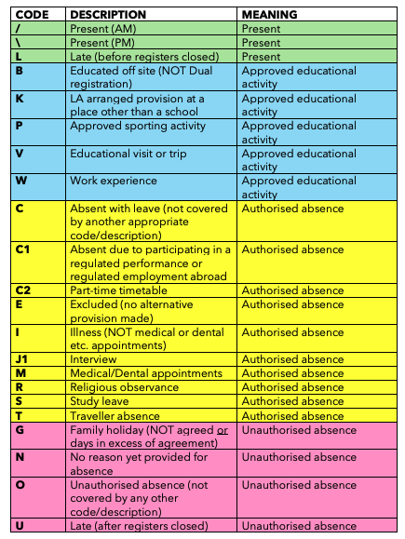

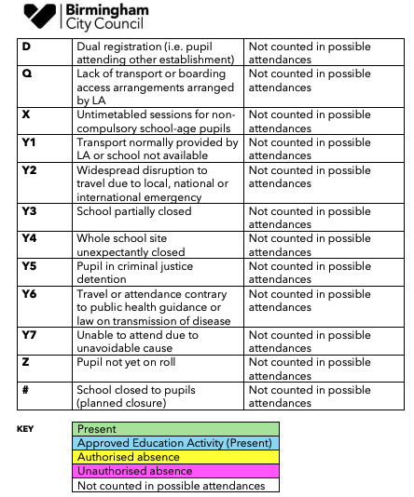

Review History | Reviewed by | Notes (significant changes / additions)
10.2.25 | FGB | Updated reference to DfE 2024 Working Together to Improve Attendance paper
 |  | Updated attendance codes applicable from Sept 2024
31.3.25 | FGB | Updated Named Governor to Liz Holmes
2.2.26 | FGB | Updated statements align with latest Ofsted expectations. Added RRSA statement

